CO1-AT2
Q9. Application: Data Backup Optimization System . A backup system uses an algorithm with recurrence T(n) = 2T(n/2) +√n. Apply the Master Theorem to determine the time complexity. Compare f(n) with n^log_b a and identify the correct case. Analyze performance for large datasets. Interpret efficiency.
Aim:
To analyze the recurrence relation T(n) = 2T(n/2) + √n using the Master Theorem, determine its time complexity, and evaluate the efficiency of the backup optimization algorithm for large datasets.
Algorithm:
Step 1: Start.
Step 2: Input the size of the dataset n.
Step 3: Define the recurrence relation:
T(n)=2T(n/2)+ √n
Step 4: Identify the Master Theorem parameters:
- a=2
- b=2
- f(n)= √n
Step 5:Compute:
n^log_b ​a=n^log_2 ​2=n
Step 6: Compare f(n) with n^{\log_b a}:
√n=n^1/2
Since n^1/2<n, apply Master Theorem Case 1.
Step 7: Therefore,
T(n)=Θ(n)
Step 8:Stop
Code:
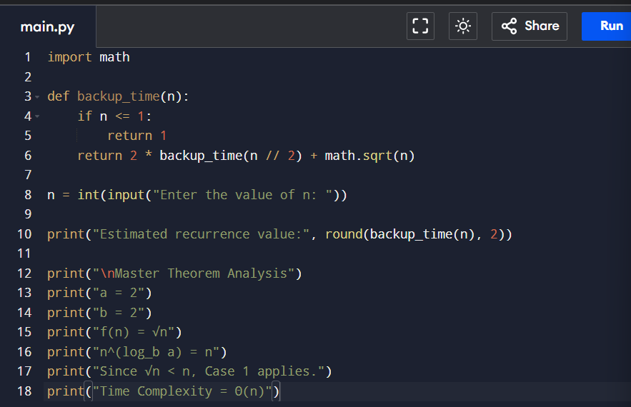
Output:
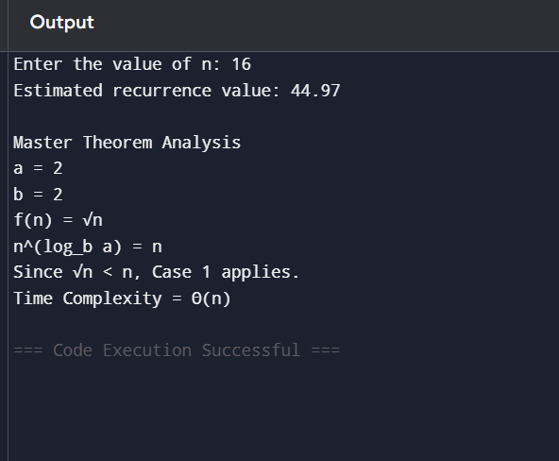

Time complexity: O(n)
Space Complexity: O(logn)
Performance Analysis for Large Datasets
- The algorithm divides the backup data into two equal parts at every step.
- The additional work at each level is only √n, which is much smaller than n.
- Therefore, the recursive calls dominate the total running time.
- The algorithm scales linearly with the input size, making it suitable for handling large backup datasets efficiently.
Result:
The recurrence relation T(n) = 2T(n/2) + √n satisfies Master Theorem Case 1, giving a time complexity of Θ(n).
Hence, the algorithm is efficient for large datasets with a space complexity of O(log n).

Q26. Application: Smart Grid Energy Distribution SystemAn energy distribution system uses the recurrence T(n)=4T(n/2)+nlog⁡n. Apply the Master Theorem to determine the time complexity. Identify parameters and justify the case selection. Analyze its performance for large energy networks. Interpret efficiency using asymptotic notation.
Aim
To analyze the recurrence relation T(n) = 4T(n/2) + n log n using the Master Theorem, determine its time complexity, and evaluate the performance of the smart grid energy distribution algorithm for large energy networks.
Algorithm
Step 1: Start.
Step 2: Input the size of the energy network (n).
Step 3: Define the recurrence relation:
T(n) = 4T(n/2) + n log n
Step 4: Identify the Master Theorem parameters:
- (a=4)
- (b=2)
- f(n)=nlogn
Step5:Compute
n^log_b _​a=nl^og_2 ​4=n^2
Step 6: Compare (f(n)) with (n^{\log_b a}):
- (nlog n<n^2)
Step 7: Since (f(n)=O(n^{2-epsilon} apply Master Theorem Case 1.
Step 8: Conclude that the recurrence relation satisfies Master Theorem Case
Step 9: Stop.

Code:
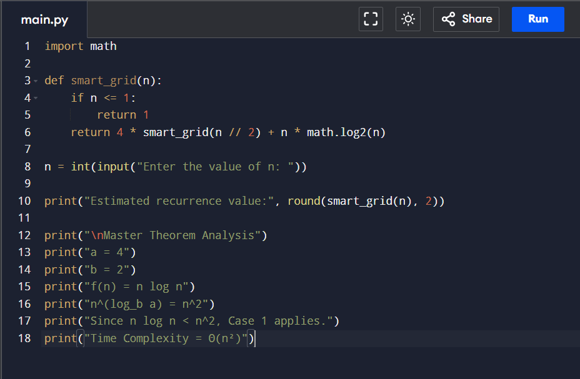
Output:
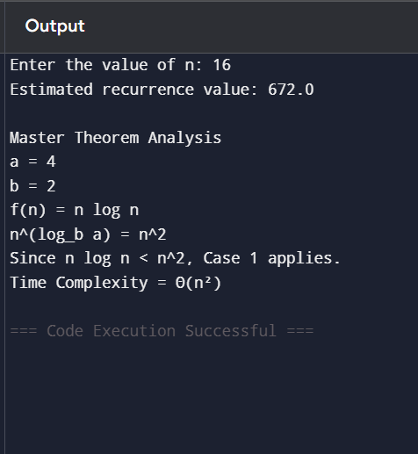

Time Complexity: Θ(n²)
Space Complexity: O(log n)
Performance Analysis
- The algorithm divides the energy network into four recursive subproblems.
- The additional work at each level is n log n, which is smaller than n².
- Therefore, the recursive part dominates the running time.
- The algorithm has quadratic time complexity, making it suitable for moderate-sized energy networks but less efficient than linear-time algorithms for extremely large networks.

Result:
The recurrence relation T(n) = 4T(n/2) + n log n satisfies Master Theorem Case 1, giving a time complexity of Θ(n²).
Hence, the algorithm has space complexity O(log n) and is efficient for moderate-sized smart grid energy distribution systems.

